Swaziland (Eswatini)

## Political Stability Estimate Data

The data set shows the political stability estimate of the country each year.

## # A tibble: 19 x 5  
## country iso3c date stability stabilityCategory4   
## <chr> <chr> <dbl> <dbl> <chr>   
## 1 Swaziland SWZ 1996 -0.207 moderately unstable  
## 2 Swaziland SWZ 1998 -0.00480 moderately unstable  
## 3 Swaziland SWZ 2000 0.0365 moderately stable   
## 4 Swaziland SWZ 2002 0.126 moderately stable   
## 5 Swaziland SWZ 2003 0.0665 moderately stable   
## 6 Swaziland SWZ 2004 -0.00530 moderately unstable  
## 7 Swaziland SWZ 2005 -0.396 moderately unstable  
## 8 Swaziland SWZ 2006 -0.273 moderately unstable  
## 9 Swaziland SWZ 2007 0.0480 moderately stable   
## 10 Swaziland SWZ 2008 -0.0793 moderately unstable  
## 11 Swaziland SWZ 2009 -0.0145 moderately unstable  
## 12 Swaziland SWZ 2010 -0.0761 moderately unstable  
## 13 Swaziland SWZ 2011 -0.480 moderately unstable  
## 14 Swaziland SWZ 2012 -0.408 moderately unstable  
## 15 Swaziland SWZ 2013 -0.432 moderately unstable  
## 16 Swaziland SWZ 2014 -0.501 moderately unstable  
## 17 Swaziland SWZ 2015 -0.476 moderately unstable  
## 18 Swaziland SWZ 2016 -0.489 moderately unstable  
## 19 Swaziland SWZ 2017 -0.300 moderately unstable

## Political Stability Estimate Plot

The plot shows the trends of stabilization and destabilization for the each country.

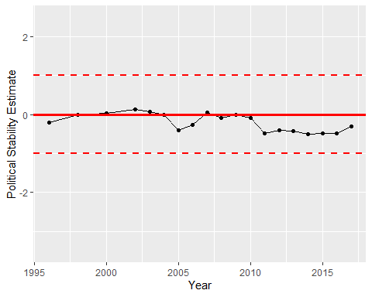

Political Stability Trend